


3GPP2 TSGs Meeting - Participants’ Information
18 – 22 August 2003, Seoul, Republic of Korea

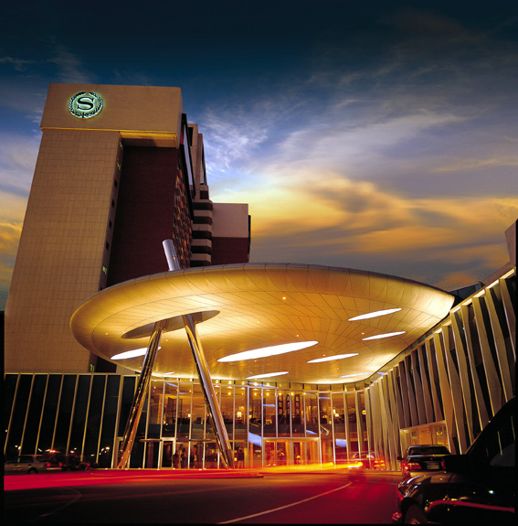
1. Venue Overview: Sheraton Grande Walkerhill Seoul
Sheraton Grande Walkerhill Seoul has a privileged location on the slopes of Mount A-Cha over viewing the river Han, surrounded by gardens and woodlands benefiting from fresh and clean air. Sited in the northeast of Seoul 90 minutes away from Incheon International Airport and 20 minutes from downtown, shopping and financial centers efficiently communicated by shuttle buses, taxis and the subway. Newly renovated it offers the business and leisure traveler the finest accommodations, entertainment, business facilities and dining available(Website: www.walkerhill.com).

2. Weather
Korea lies in the Temperate Zone and has four distinct seasons: spring, summer, fall, and winter. Summer begins from June and lasts until August. During the Conference period, the weather will be sunny and humid, and the temperature will be in the range of 23-30℃(73-86℉). Korea will give you great pleasure as a good place for your summer vacation.

3. Business Hours
Bank business hours are from 9:30am to 4:30pm on weekday. Major department stores are open from 10:30am to 7:30pm, including Sundays, Smaller shops tend to be open from early morning until late seven days a week.

4. Electricity
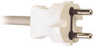
Only 220 volts is available in all the meeting venues. However, outlet for both 110 and 220 volts are available in all guest rooms at Sheraton Grande Walkerhill Hotel.
5. Lan Facilities
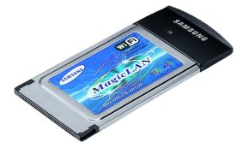
The whole meeting place will be fully covered by wireless LAN(IEEE 802.11B).

6. Free Internet Access
The Conference participants staying at Walkerhill are favored with free internet access at their rooms. For this service, please make sure to inform the hotel that you are attending the “3GPP2” meeting when making your booking.

7. Transportation

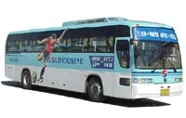
1) Airport to Hotel
To get to Sheraton Grande Walkerhill Hotel, we recommend you to take KAL limousine bus from the airport. This bus is the most convenient way to travel from the Incheon International Airport to the the hotel. This spacious 25-seat luxury bus is equipped with public telephone, and stops at 17 of Seoul's major deluxe hotels.

(1) KAL Limousine Bus (Strongly recommended)
The KAL Limousine Bus runs between Sheraton Grande Walkerhill Hotel and Incheon International Airport. at every 20~30 minutes. (05:45~22:35)
* Fare : ￦ 12,000
* Departure : Bus Stop 4B, 11A(Arrival Curbside)
* Bus Line : Line 4
* Bus Stop : Incheon Airport → Lotte World Hotel → Dong Seoul Terminal → Sheraton Grande Wakerhill Hotel

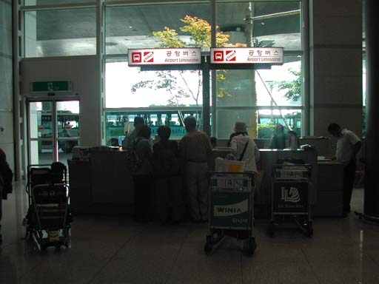
* Buying a ticket: At near to Exit Number #5, you can buy the Ticket for Airport Limousine Bus from the Airport to Walkerhill Hotel. Please see the right picture.

(2) Taxi
Average fare from the Incheon International Airport to downtown Seoul is about ￦ 40,000 ~ ￦ 55,000 (USD 30 ~ 43) in a standard taxi and ￦60,000 ~ ￦80,000 (USD 46 ~62) in a deluxe taxi(black car with yellow light) but it may cost more depending on traffic during rush hours. Please note that there is additional charge of 20% from midnight to 4 a.m.
More information of Incheon International Airport can be found from their homepage at ( http://airport.or.kr ).
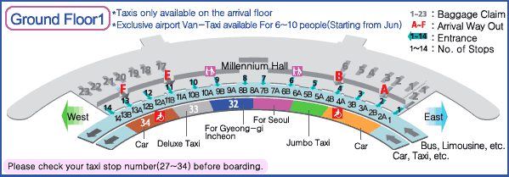

2) Free Shuttle Bus Service of Walkerhill
Sheraton Grande Walkerhill Hotel offers shuttle bus service free of charge for your convenience.

- Subway Station Course (Operation Hours : 06:00am ~11:30pm)
Destination : Gangbyun Station(Line 2) , Gwangnaru Station(Line 5)
Departs every 20 minutes
- Dongdaemoon Shopping District Course (Once a day)
Departs from Sheraton Grande Walkerhill : 10:30 pm
Departs from Dongdaemoon Shopping District : 1:30 am
Not Available on Monday.

8. Guest Rooms & Amenities

Designed with comfort and luxury in mind, all of the rooms provide guests with
remote color TV, pay movies, radio, safety deposit box and bathroom, refrigerator with mini bar, key card security, direct dial phones and voice message service.
(Room guests will receive a special discount on Tennis Court, Golf Driving Range,
free admission to Fitness Club)
1) Main Deluxe
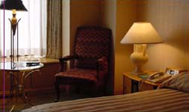
Main Building from 3rd to 11th floor, are 368 rooms,
where the guest can experience a wonderful sight
of the Han river and A-cha Mountain.

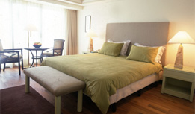
2) Douglas Executive Club
The Douglas Executive Club offers business services
with a private atmosphere. Designed specifically for the
International business traveler, it is located in its own
separate section of the SWH complex.

* Special benefits for DEC guests
- Airport Service (One way from airport to hotel)
- Complimentary American Breakfast at DEC Lounge.
- Happy hour (6:00 p.m. - 8:00 p.m.) with cocktails and snacks at DEC Lounge.
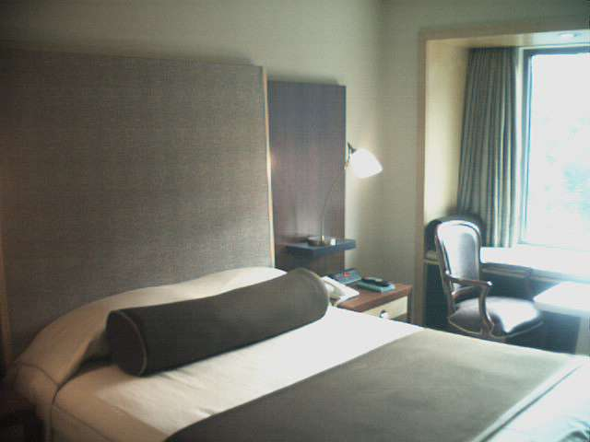
3) Towers
The finest in amenities and personal Butler service,
located on the top five floors. Sheraton Towers'
rooms are the most luxurious and spacious in Seoul,
and are designed for the frequent traveler who
appreciates and expects the finest a hotel have to offer.

* Special benefits for Towers guests
- Airport Service (One way from airport to hotel / Round trip for only Towers Suite guests.)
- Complimentary American Breakfast at Towers Lounge.
- Happy hour at Towers Lounge, Butler Service(24 hours)

9. Entertainment

1) Walkerhill Show
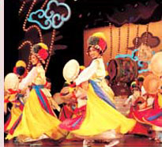


Offering fine dining, traditional Korean dance and Magic on Ice, which is recognized as the world’s premier ice skating show. Taking you on a trip back in time, space and to far away place
Time Schedule : 1st Show at 4:30pm 2nd Show at 7:30pm

2) Walkerhill Casino
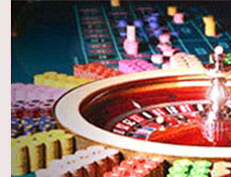
24 hour action at the only casino in Seoul, games include;
Slot machines and Blackjack, Craps, Baccarat, Tai Sai, Roulette, with private rooms available for high stakes betting.

3) Duty Free
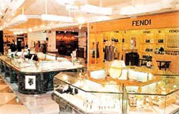
Located adjacent to the Main Lobby and newly renovated, it offers three floors of boutique shops and goods from famous international brands like Christian Dior, Gucci, Piaget, Bvlgari, etc. The comfort, selection and prices provide for a complete shopping experience.

4) Recreational Facilities
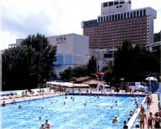

- Indoor ,Outdoor Pool
- Golf Driving Range
- Tennis Courts
- Fitness Facility

